|  |  |  |  |
| --- | --- | --- | --- |
| **Fr. Conceicao Rodrigues College of Engineering**  **Department of Computer Engineering** | | | |
| **Student’s Roll No** |  | **Students Name** |  |
| **Date of Performance** |  | **SE Computer – Div** | **A / B** |

**Aim:** To study basics of Shell Scripting

**Lab Outcome:**

**CSL403.1: Demonstrate basic Operating system Commands, Shell scripts, System Calls and API wrt Linux.**

**Problem Statements:**

1. WAP that accepts user name and reports if user logged in.

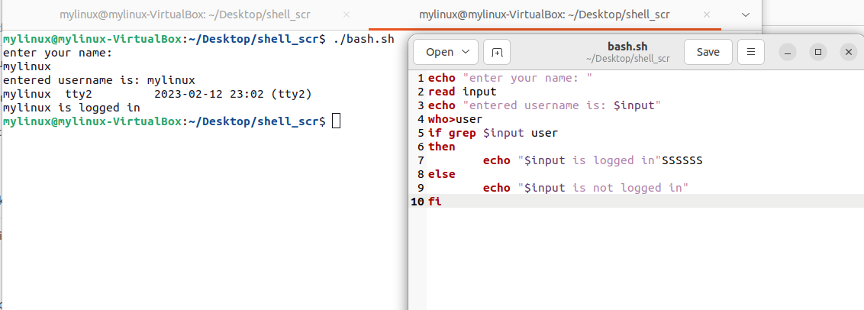

1. WAP that takes a filename as input and checks if it is executable, if not make it executable.

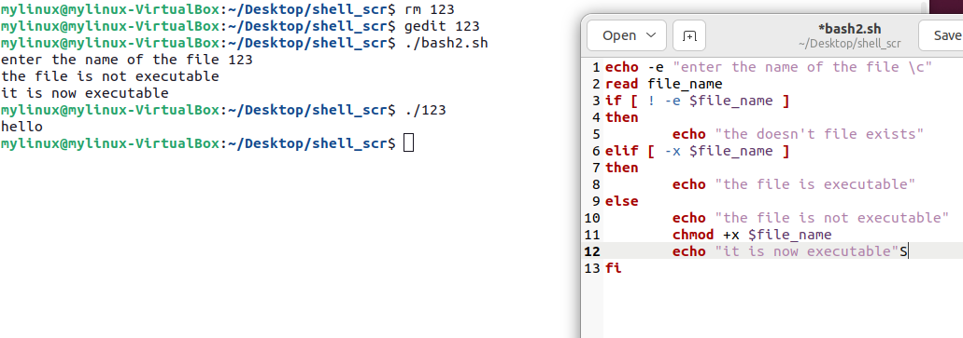

1. WAP to take string as command line argument and reverse it.

1. Write a shell script to find the sum, the average and the product of the four integers entered

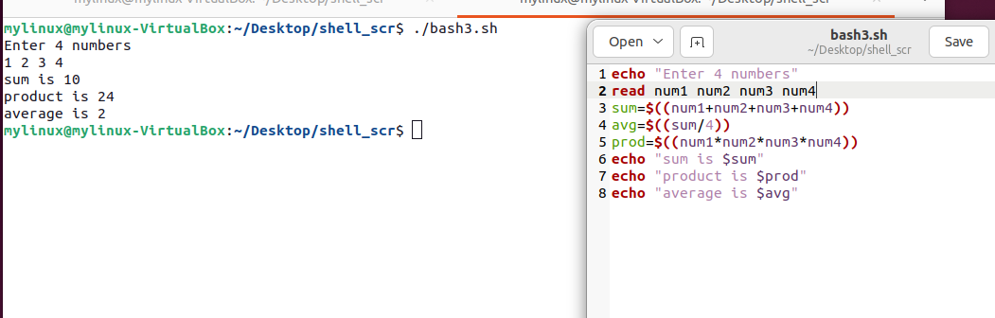

1. Write a shell script to find out the unique words in a file and also count the occurrence of each of these words. We can say that the file under consideration contains many lines, and each line has multiple words.B

1. WAP which displays the following menu and executes the option selected by user:

1.ls 2. pwd 3. ls –l 4. ps -fe

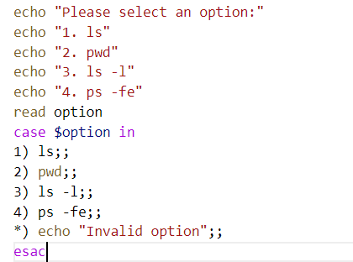

1. WAP that prompts user for a starting value & counts down from there.

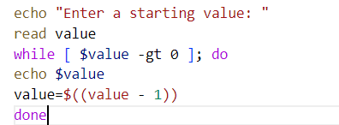

1. Create a data file called employee in the format given below:

EmpCode  Character, EmpName   Character , Grade  Character , Years of experience Numeric , Basic Pay   Numeric

* + Sort the file on EmpName.
  + Sort the file on

Decreasing order of basic pay

Increasing order of years of experience.

Display the number of employees whose details are included in the file.

Display all records with ‘smith’ a part of employee name.

Display all records with EmpName starting with ‘B’.

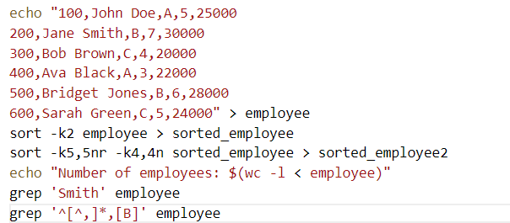

**References:**

<https://www.tutorialspoint.com/unix/shell_scripting.htm>

<https://www.tutorialspoint.com/unix/unix-what-is-shell.htm>

<https://www.tutorialspoint.com/unix/unix-using-variables.htm>

<https://www.tutorialspoint.com/unix/unix-special-variables.htm>

<https://www.tutorialspoint.com/unix/unix-using-arrays.htm>

<https://www.tutorialspoint.com/unix/unix-basic-operators.htm>

<https://www.tutorialspoint.com/unix/unix-decision-making.htm>

<https://www.tutorialspoint.com/unix/unix-shell-loops.htm>

|  |  |  |  |
| --- | --- | --- | --- |
| **On time Submission(2)** | **Knowledge of Topic(4)** | **Implementation and Demonstraion(4)** | **Total (10)** |
|  |  |  |  |
| **Signature of Faculty** |  | **Date of Submission** |  |